Audio video mid term

Answer 1: The letter ‘A’ represents the “compression” or “amplitude”.

Answer 2: The letter ‘B’ represents the “Wave length”.

Answer3:

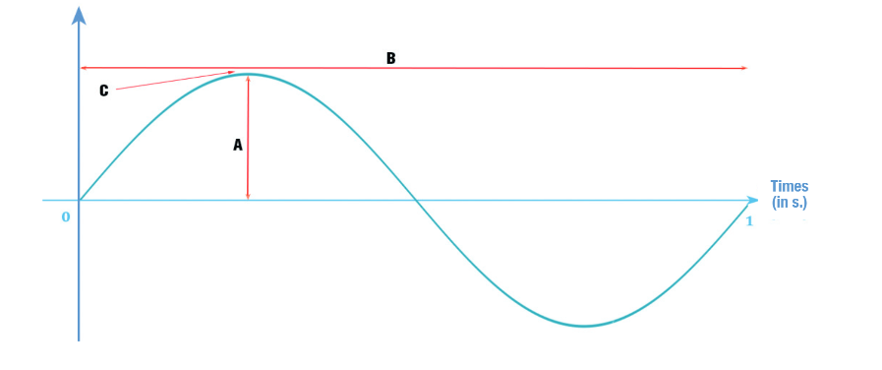

360 degree

Half turn 

270 degree

Quarter turn

180 degree

90 degree

Answer 4: The term we use to designate the highest point of a sound wave is called “Crest”.

Answer 5 = check zip folder